

**Online Monitoring and Supervision System**

**User’s Manual**

Table of Contents

Chapter 1: General Information 1

Log in to M&S System 2

Downloadable Checklists page 3

Main Interface/Screen 4

Chapter 2: Visit Plan Making by Supervisors and submission of Checklists 5

Plan Making 6

List of Plans made 6

Plan View 7

Make Plan 8

Submission of Checklists 10

Chapter 3: Plan Approval by DHO 11

Plan Approval by DHO 12

View of Approved Plan 13

All Plan View 14

Chapter 4: Plan Approval by DGHS 16

DG Plan View and Approval 17

All Plan View with Drilldown facility 18

# Chapter 1: General Information

## Log in to M&S System

To login in the Online M&S software, follow the instructions provided here;

Type the web address checklists.dhissindh.pk here in your browser to open the M&S application login page.

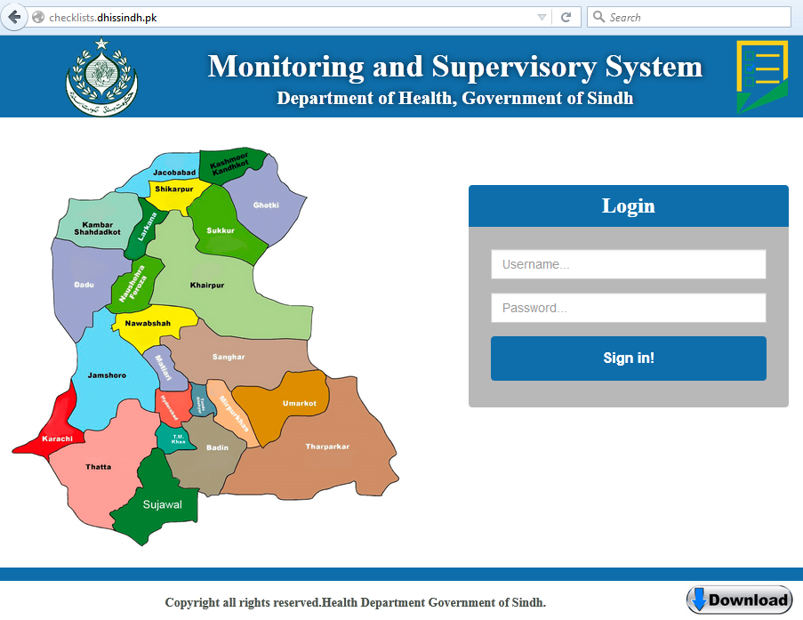

Clicking on Download will take you to the page containing all downloadable checklists without logging in to the system

Enter your **Username** here, this is case sensitive input.

Enter your **Password** here, this is case sensitive input.

After entering your User name and Password, Click **Login** button

## Downloadable Checklists page

This page consists of all checklists in downloadable word and pdf formats. Supervisors may download these checklists and forms to make monthly visits plan. Before entering data of visit plan and filled checklists into online system, these forms may be filled by supervisors during health facilities visits

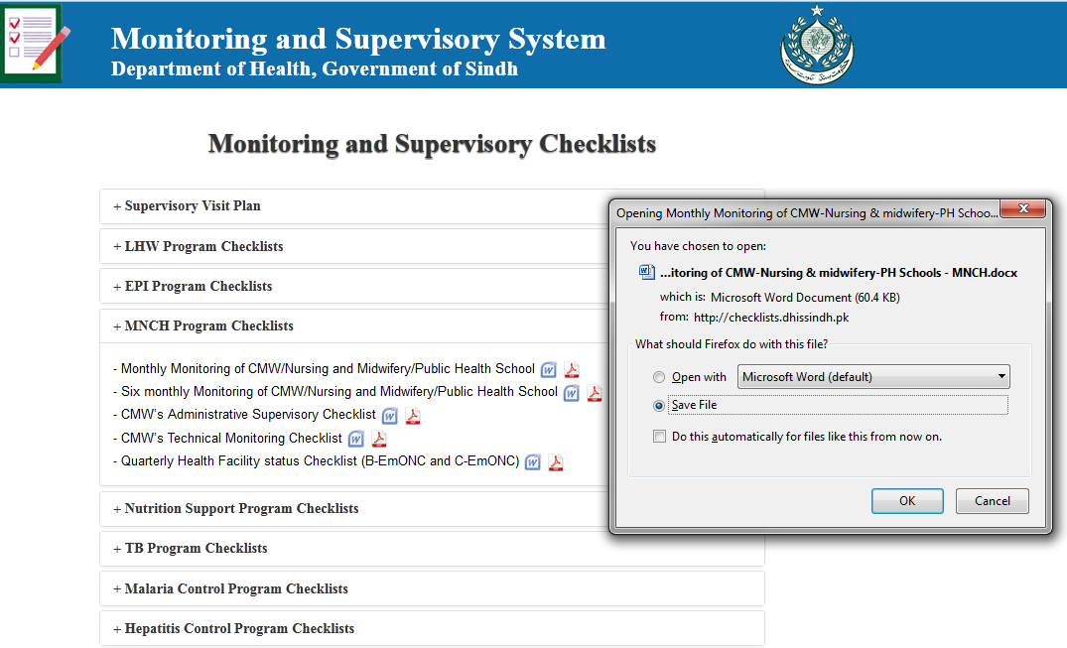

Downloadable Supervisory checklists

File download dialog box after clicking on word or pdf icon

Click + to explore list of checklists in this section

## Main Interface/Screen

After login in, following screen will be appeared in your web browser; top left hand side showing the logo of province and the top right hand side show the details of supervisors login, designations and program. After header, there is menubar contain all options to interact with system

District name

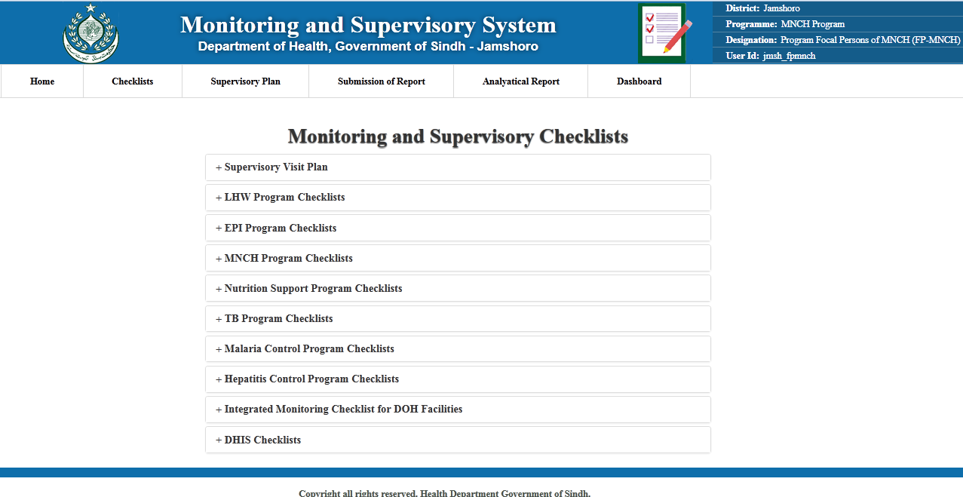

Downloadable checklists links

Menu bar showing the different options for working

Program, Designation and login id of Supervisor logged in the System

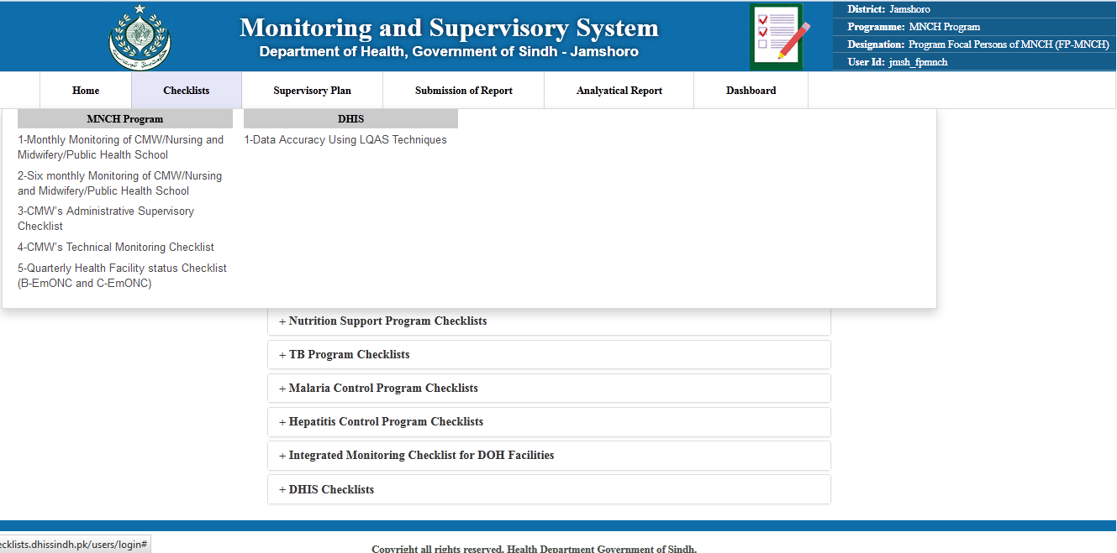

Menu Options for MNCH Supervisor. Every supervisor will see checklists of their relevant programs

# 

# Chapter 2: Visit Plan Making by Supervisors and submission of Checklists

## 

## Plan Making

Every district and provincial supervisor may make his own plan. To add/edit or view his plan, supervisor has to click on My Plan in menu as shown the following.

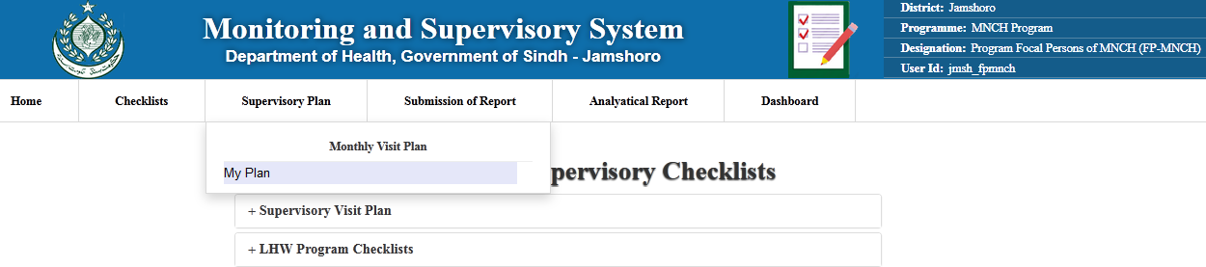

Supervisor will click on My plan to add/edit of view their plans

## List of Plans made

Next screen appear will contain the list of plans made by the supervisor. This list contains information like Supervisor name, District, Year month, supervisors program, No of visits planed, plan submission date, information whether plan is approved by DHO and view button to see the details of plan

On top of list, there is a link “Make Plan”, clicking on this will open the interface to make new plan.

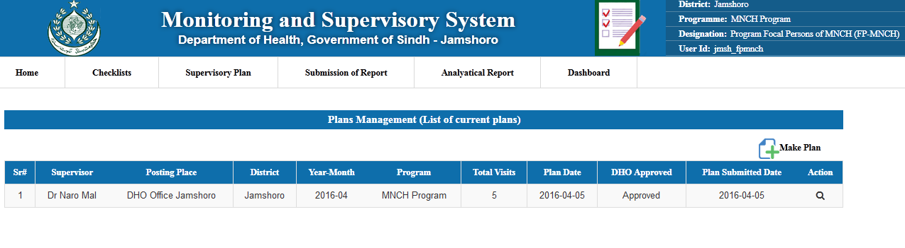

Click here to make new plan

Click here to see the details of plan

List of plans made by supervisor

## Plan View

Clicking on Plan view will open the page containing details of plan. These details include information about Supervisor who made the plan, year-month of the plan, details about each planned visit which includes visit category (DAP visit / Program visits), Facility type, Facility to be visited, Checklist names to be filled during visit, Healthcare providers name whose checklist is to be filled, date of visit planned.

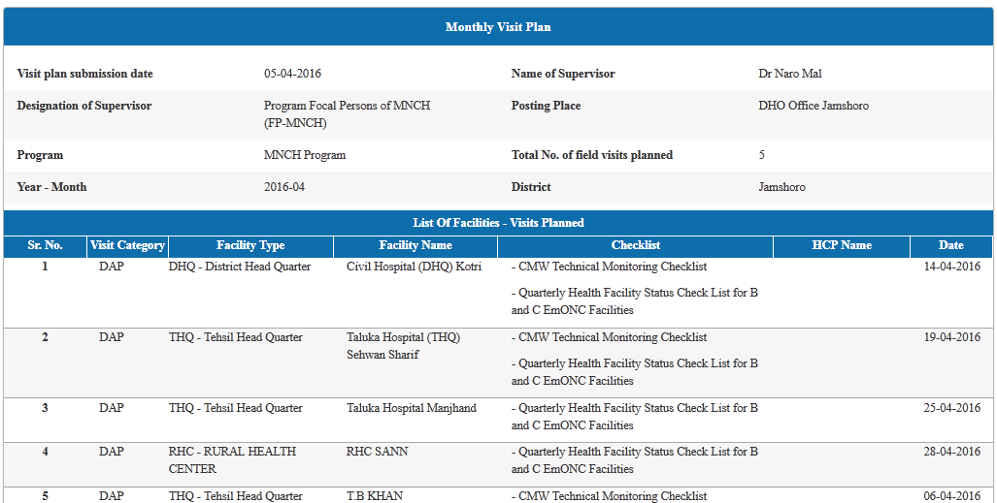

Details of supervisor information and plan year month

Dates of Visit planed

Health Facility name to be visited

Selected Checklists to be filled during planned visit

## Make Plan

By clicking on Make plan, interface of making new plan for the month will be appeared. This interface will facilitate supervisors to make plan for coming month, by selecting visit category, health facility to be visited, checklist to be filled and any particular health care provider whose checklist to be filled like CMW, LHW and any SBA, and dates when health facilities will be visited in plan. Following figures show the functioning of Make new plan

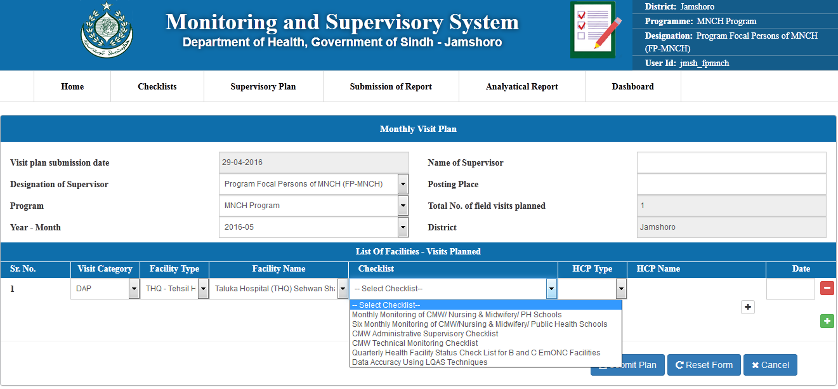

Checklists to be filled during visit.

This button allows to add more then one checklist to be filled during visit

Visit Category is either DAP or Routine Vertical Program

Year-Month of the plan

To enter name of supervisor and posting place

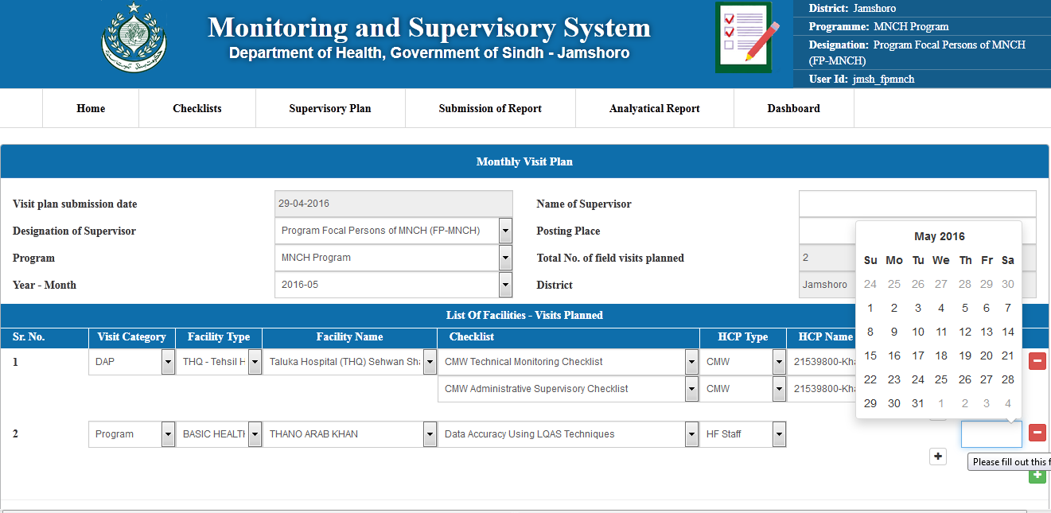

Date of the visit

Date of the visit

This button allows to add new visit

Healthcare provider to be selected whose checklists to be filled

Facility to be visited

Facility type will filter the facility of particular types

* Visit plan is editable until approved by DHO. After the approval of DHO, this plan may not be changed
* Supervisor has facility to select as many checklists he want to filled during one visit
* Supervisor may add as many visit as he wants to include in plan
* One supervisor may make only one plan for a month. If plan already exist, then following message will appear

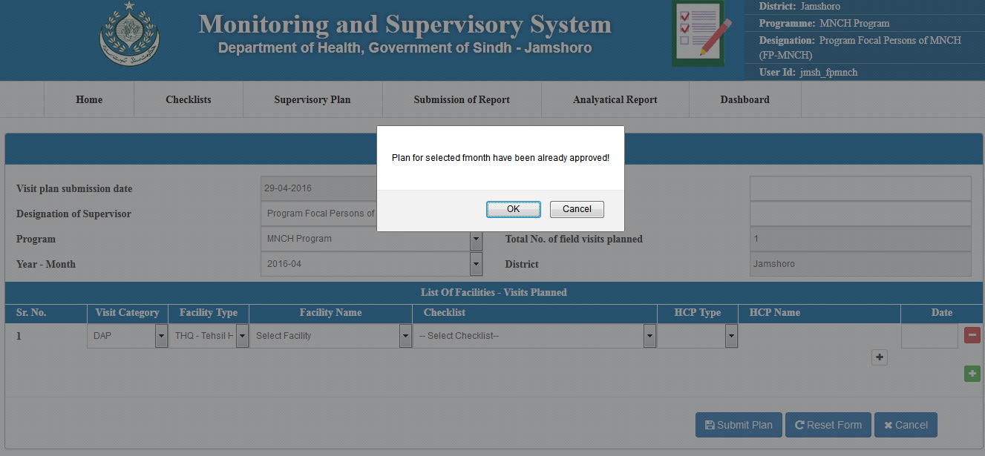

## Submission of Checklists

After the plan is made, and DHO will approve the plan, Supervisors will visit facilities and fill checklists during their visits as per plan. Then supervisors will be able submit data of this checklist in online system. For submission of checklist, Supervisor will click on Submission of Report” which will give month list whose plans are available.

Submission of Report  
List of month whose plan are available for submission

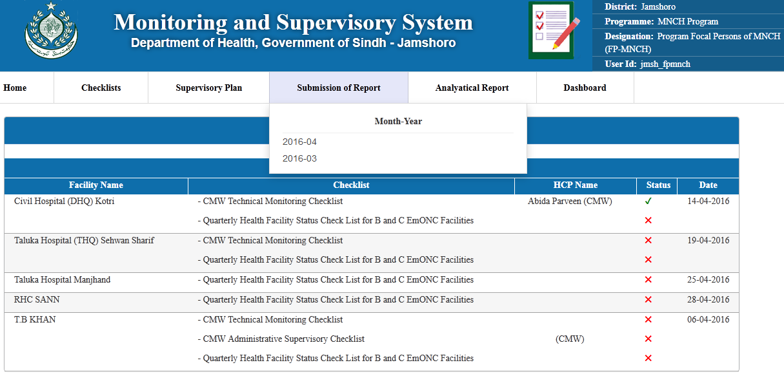

“**√**” or “**X**” tells the status of checklist filled

Click on checklist to enter checklist data online

# Chapter 3: Plan Approval by DHO

## Plan Approval by DHO

For district supervisor, DHO is allowed to approve the plan in this system. Similarly, for provincial supervisor of vertical programs, Provincial program director is allowed to approve the plan. DHO or Provincial program director will first login to the system.

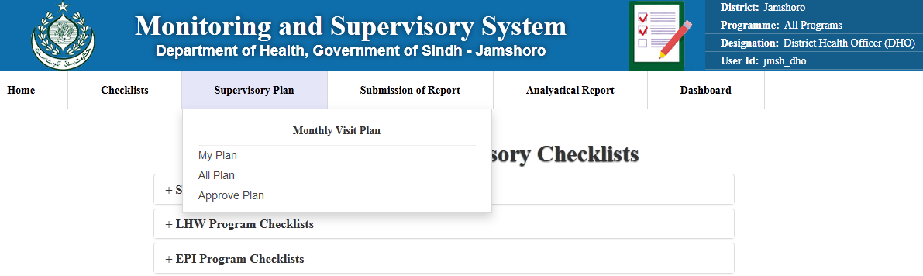

Approve Plan

DHO Login

DHO will be able to see full list of checklists in menu

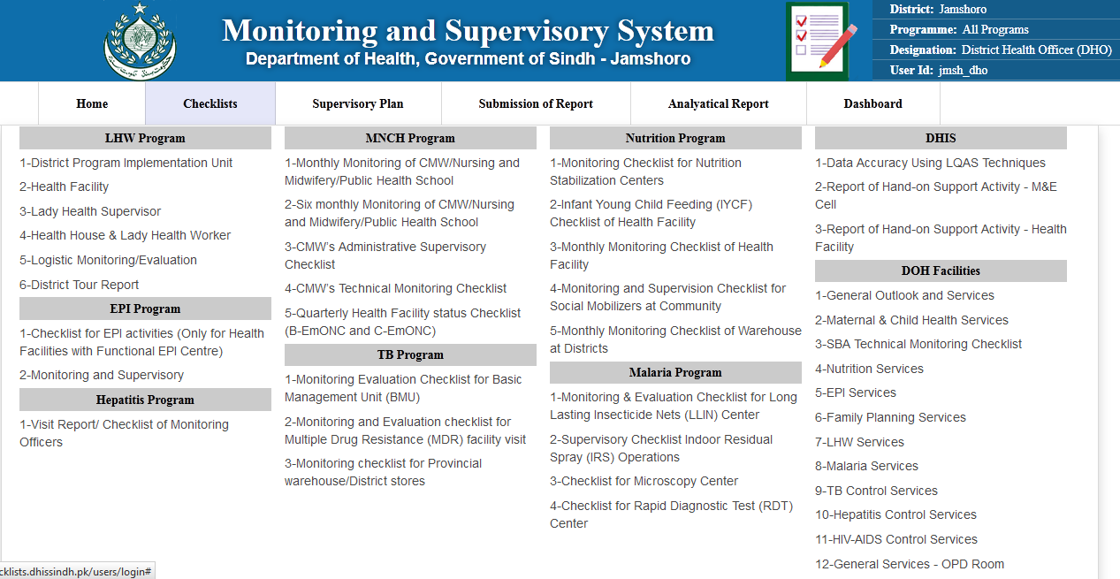

After clicking Approve Plan following screen will appear. Here DHO may adjust visit dates of plans of supervisors, and can make overall visit plans optimal. DHO can also assign Vehicles and Drivers for team visits

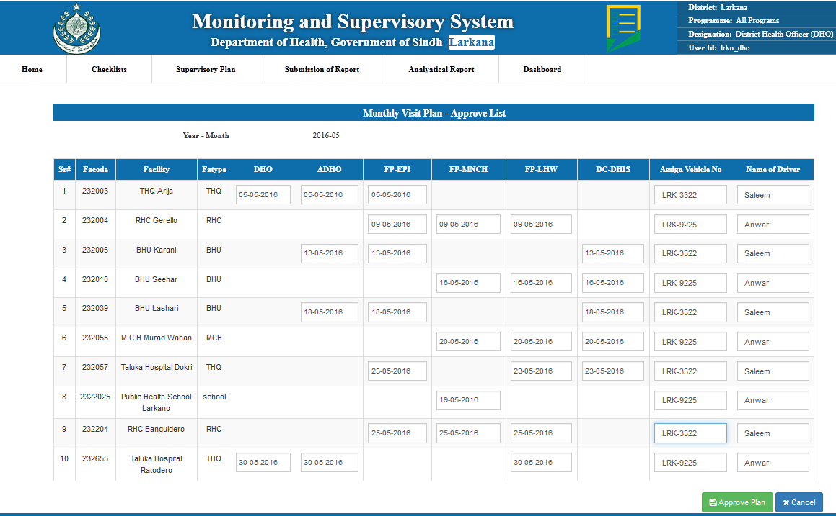

DHO will click this button to finalize and approve Plan

DHO may assign Drivers and Vehicle for team Visits

Dates of Supervisor may be adjusted by DHO to optimize the plan

## View of Approved Plan

DHO may view his approved plan by clicking on view in plan lists

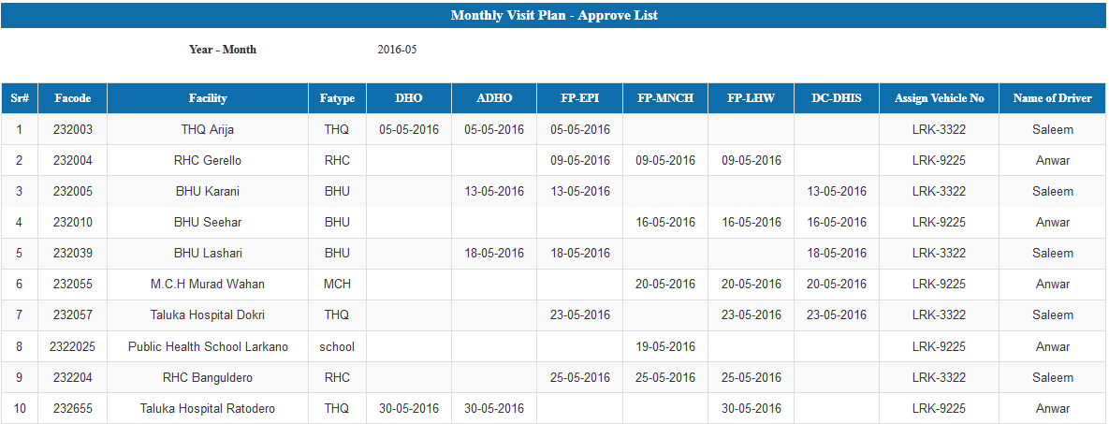

## All Plan View

DHO may have view of all plans by clicking All Plan in menu of Supervisory Plans. Following is the view of All plans for DHO

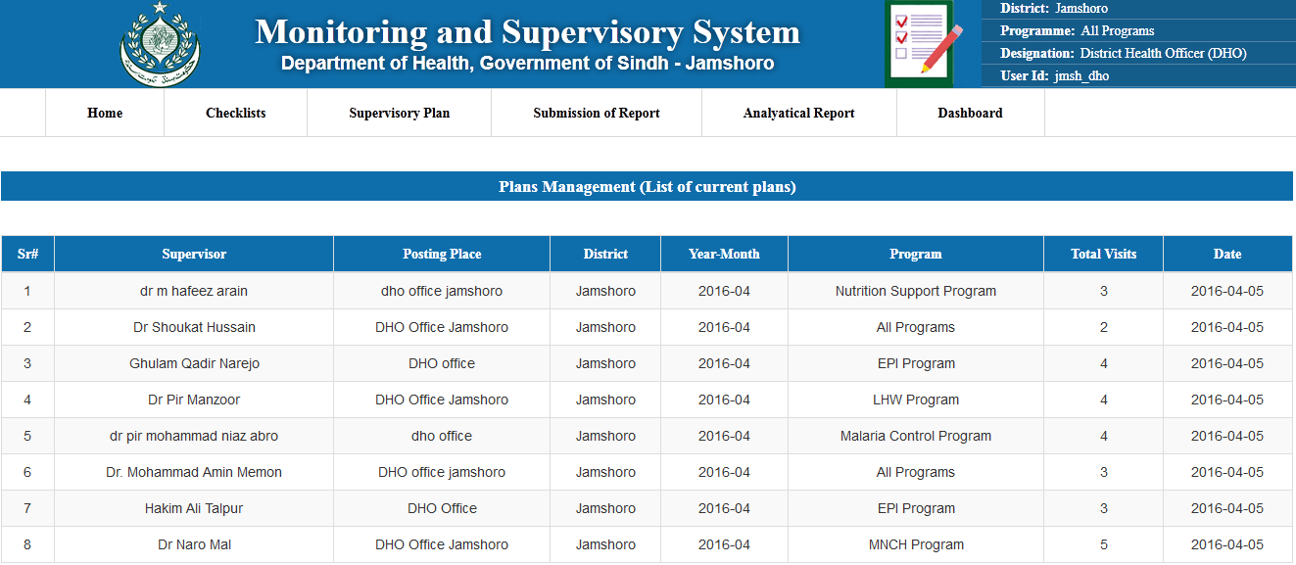

Clicking on any row will give drill down plan view of any supervisor

Drill down view of plan after clicking on any row of all plan view of DHO

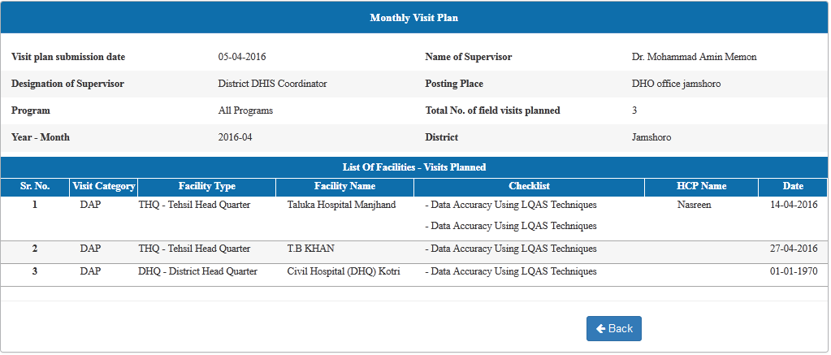

Clicking on Checklist will give view of filled checklist as drilldown

Then in plan detailed view, DHO may click on any checklist, it will open view of filled checklist as drilldown

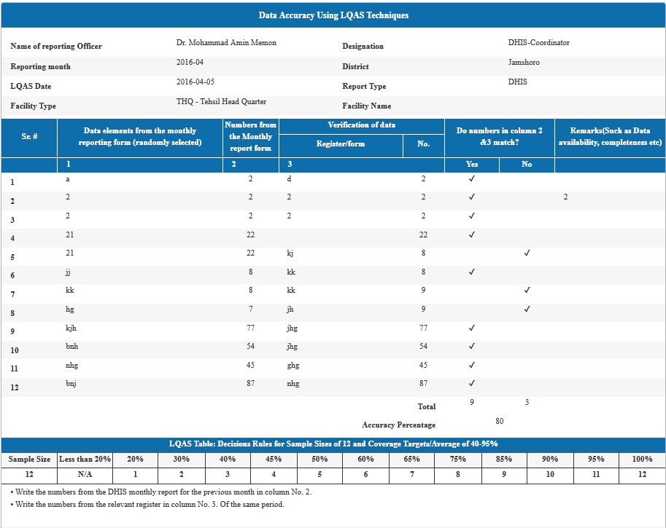

This is view of sampled filled checklist of Data Accuracy using LQAS techniques. This view is showing that this checklist is filled by DHIS-Coordinator for reporting month April 2016.

# Chapter 4: Plan Approval by DGHS

## DG Plan View and Approval

DG health also can view all plans made by supervisor and approved by DHOs.

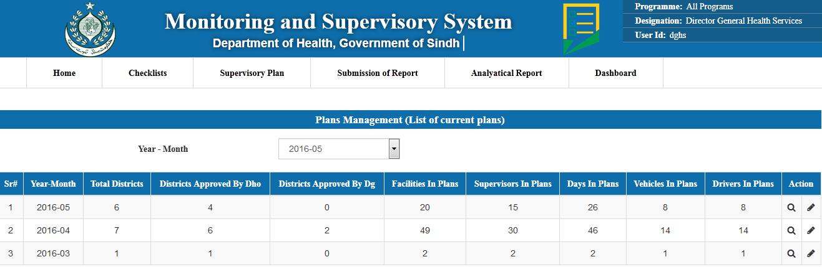

Clicking on Edit button, following approval page will be opened. DGHS can approve all plans at once or may approve district plans one by one

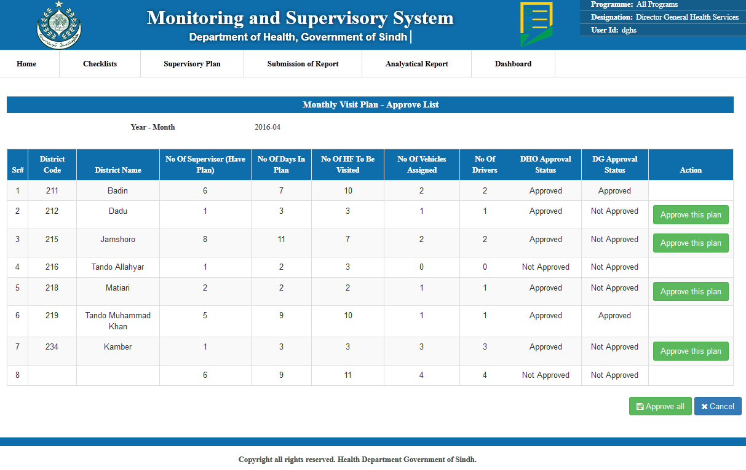

## All Plan View with Drilldown facility

DGHS may view all plans by clicking on All Plan in menu of Supervisory plans. View of all plans will be as follows.

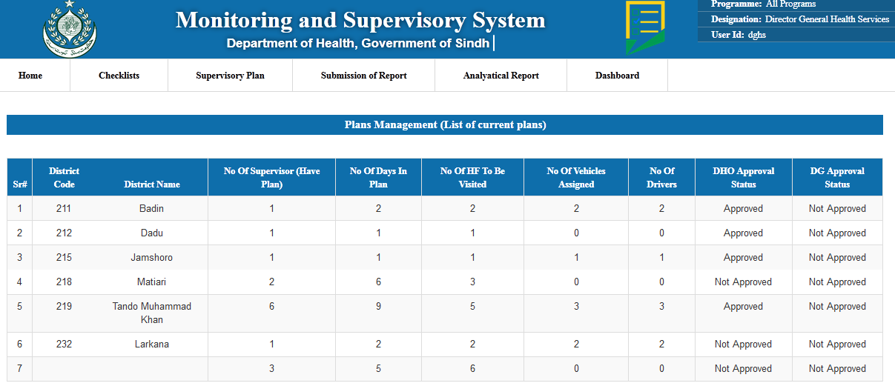

This view of all plans gives information about plans submitted as district wise aggregates. This view includes no of supervisor who have made their plans, No of days in plan for every district, No of Health facilities to be visited, No of vehicles to be used or assigned, No of Drivers assigned against district’s plan. This view has the features of drilldown therefore DGHS may click on any row and get the view of details of districts which is show in following snapshot

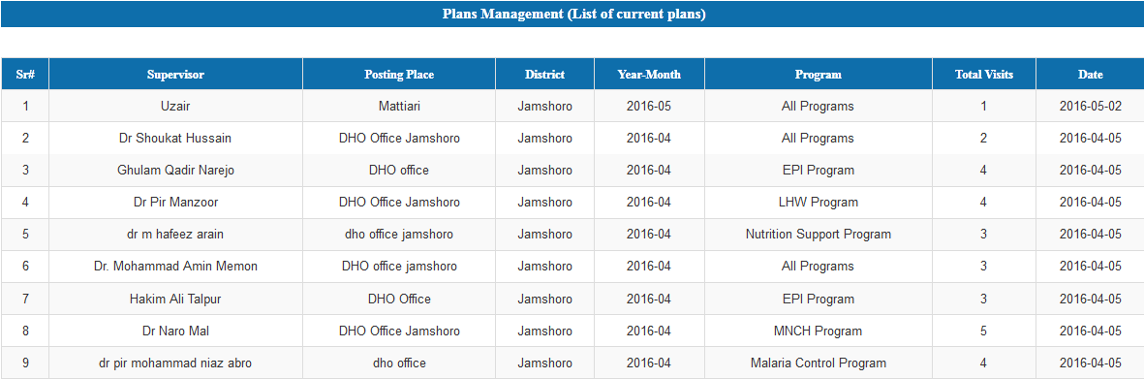

This view have further drilldown facility which similar as discussed in DHO level all view plans and DGHS can see the individual checklist filled using this drilldown facility